Macintosh HD:Users:James:Google Drive:rest:Bluesat:Promotional/Recruiting:Logo:blues student space projects.pdf

**Australia’s Undergraduate Space Group**

**Proposal for Industry Partnership**

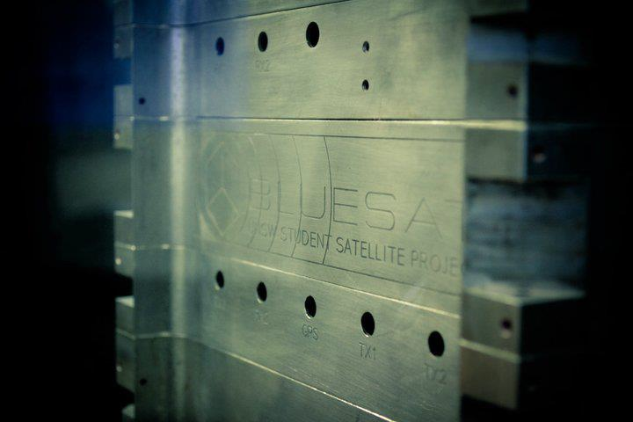

Presented by

**BLUEsat**

University of New South Wales

Sydney, Australia

# Contents

# 

Contents 2

1 Overview of the BLUEsat Project 3

1.1 Background Information 4

1.2 BLUEsat Satellite Specifications 5

2 BLUEsat’s Future 6

2.1 Test Flight 6

2.2 Canadian Space Design Challenge 6

2.3 NASA Lunabotics 6

3 Industry Partnership 8

3.1 BLUEsat Financial Objectives 8

Canadian Satellite Design Challenge 9

Appendices 11

Appenidx A – BLUEsat Projectd Budget 11

# Overview of the BLUEsat Project

The first BLUEsat satellite is an amateur radio satellite that has been entirely designed and built by undergraduate students at the University of New South Wales (UNSW). The satellite was completed in July of 2013.

Today, the BLUEsat Group is made up of dedicated undergraduate engineering students at UNSW with an interest in space engineering. We are currently expanding into multiple student space engineering projects, each with a time frame of less than 2 years. Our team is primarily made up of talented Electrical, Mechanical and Software engineering students.

The aim of the BLUEsat Group is to:

* Provide UNSW Students with an opportunity to design, build and launch Space Hardware
* Teach students practical design and project management skills in the space-engineering field.
* Raise the profile of BLUEsat, UNSW and its sponsors by successfully competing in international Space Design Challenges.

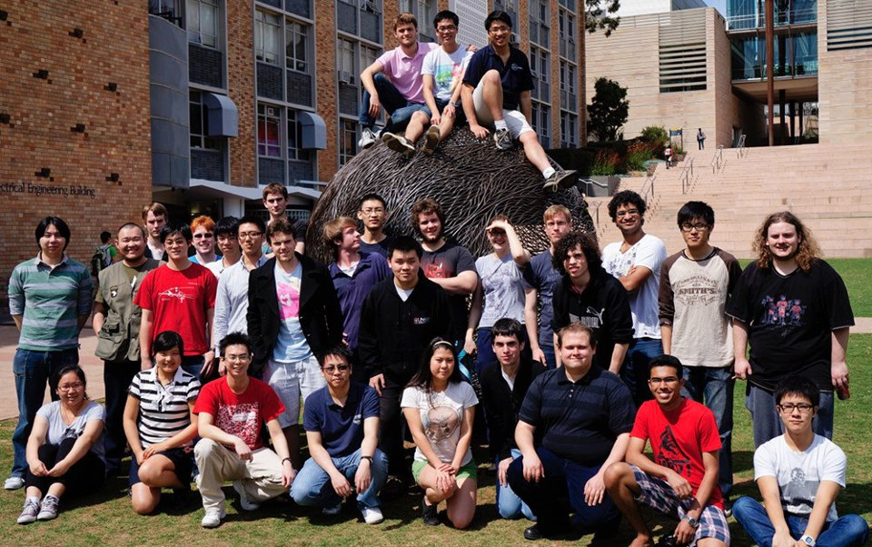

Figure 1 - The BLUEsat Team

## Background Information

BLUEsat’s first major project was completed under the Warrawal Project. The Warrawal Project was a space educational program arising from the government-funded Australian Space Research Program (ASRP). The aim of the project was to create space-engineering educational opportunities within Australia.

As part of the project, the first BLUEsat microsatellite was to have a fully functional model by mid-2013. This deadline was successfully met, with the complete demonstration to the final Warrawal Consortium Conference taking place in July 2013.

BLUEsat is now re-building a flight model of the working satellite to undergo a test launch in April 2014. We are also embarking on two future projects that will become the main objective of the BLUEsat team after the launch – competing in global space-engineering design competitions and building a QB-50 CubeSat.

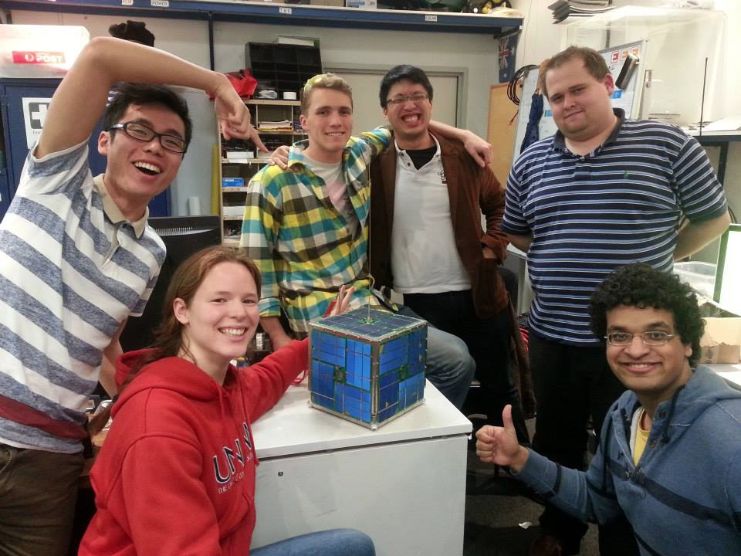

Figure 2 - Finished BLUEsat satellite before the Warrawal Consortium demonstration.

## BLUEsat Satellite Specifications

The BLUEsat microsatellite is an amateur radio satellite based on the original AMSAT design. It consists of an aluminium structure (pictured below) that is broken up into five trays. Four of the trays contain critical system components and the fifth tray carries the payload.

The payload will consist of the Namura Experimental GPS, a small array of sensors and two cameras. One camera will be positioned to photograph the curvature of the Earth and the second camera will face the satellite to document the flight.

Satellite Mass: 9kg

**Dimensions**:23x23x23cm (Without Antennas)

23x23x90cm (With Antennas)

**Frequencies**: 145.95 MHz (Receiving)

436.54 MHz (Transmitting)

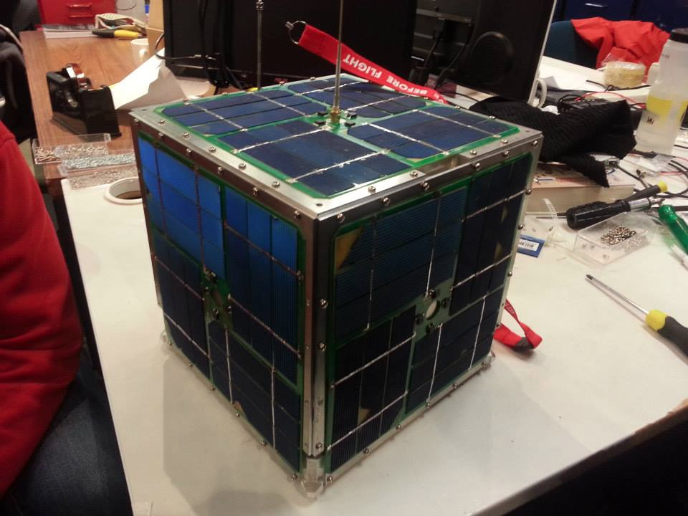

Figure 3 - Finished Satellite Structure

Industry Partnership Proposal

# BLUEsat’s Future

With the first satellite project completed, the BLUEsat Group is heavily recruiting and expanding for the future. The Group will focus on undertaking three main projects – the Test Flight for the first Satellite, the Canadian Space Design Challenge (CSDC) and the NASA Lunabotics competition.

## Test Flight

In April 2014, a stratospheric balloon launch will completely test the capabilities of the BLUEsat satellite under space conditions. This will allow for an effective telemetry sweep and comprehensive tests of the entire system. It will also provide us with important feedback on the satellite’s performance in a radiation environment.

This will make BLUEsat the first satellite to reach space that is completely designed and built by undergraduate students.

There are several different flight durations available for the test launch, with longer flights providing a greater scientific and engineering return. Our goal is to test BLUEsat at a height of 40km for 24 hours, however this presents a significant financial investment for a student project.

BLUEsat would like to partner with ___(company)__ to work together and ensure this remarkable achievement can be accomplished together.

## Canadian Space Design Challenge

The CSDC is a Canadian run CubeSat design competition. The competition calls for the design and delivery of a 3U CubeSat, with 21 months between registration and satellite delivery. The CSDC also requires that entrants participate in high-school outreach and science educational programs in order to increase space-technology awareness in the public community. In the past, the CSDC has had some international involvement, with a partnership between the University of Bologna and École Polytechnique de Montréal.

BLUEsat has contacted the CSDC administrators with support from the Australian Centre for Space Engineering Research (ACSER). The CSDC has given a positive response, encouraging UNSW to partner with a Canadian University in order to field an entrant into the next cycle of satellites, expected to be delivered in mid-2015. Liaising with the CSDC to organise a partnership is ongoing.

Industry Partnership Proposal

## NASA Lunabotics

The NASA Lunabotics Mining Competition requires university student groups to design and build an un-manned rover designed for operation on the moon. The challenge runs annually, with competitions held at the Kennedy Space Centre in Florida. International universities make up a significant number of entrants each year. Like the CSDC, the Lunabotics competition also requires student groups to perform high school outreach.

The BLUEsat Lunabotics team is currently working on an initial conceptual design, project plan and budget. The aim is to have a semi-functional model by end of Semester 1, 2014 and a rover ready for entrance to the May 2015 competition.

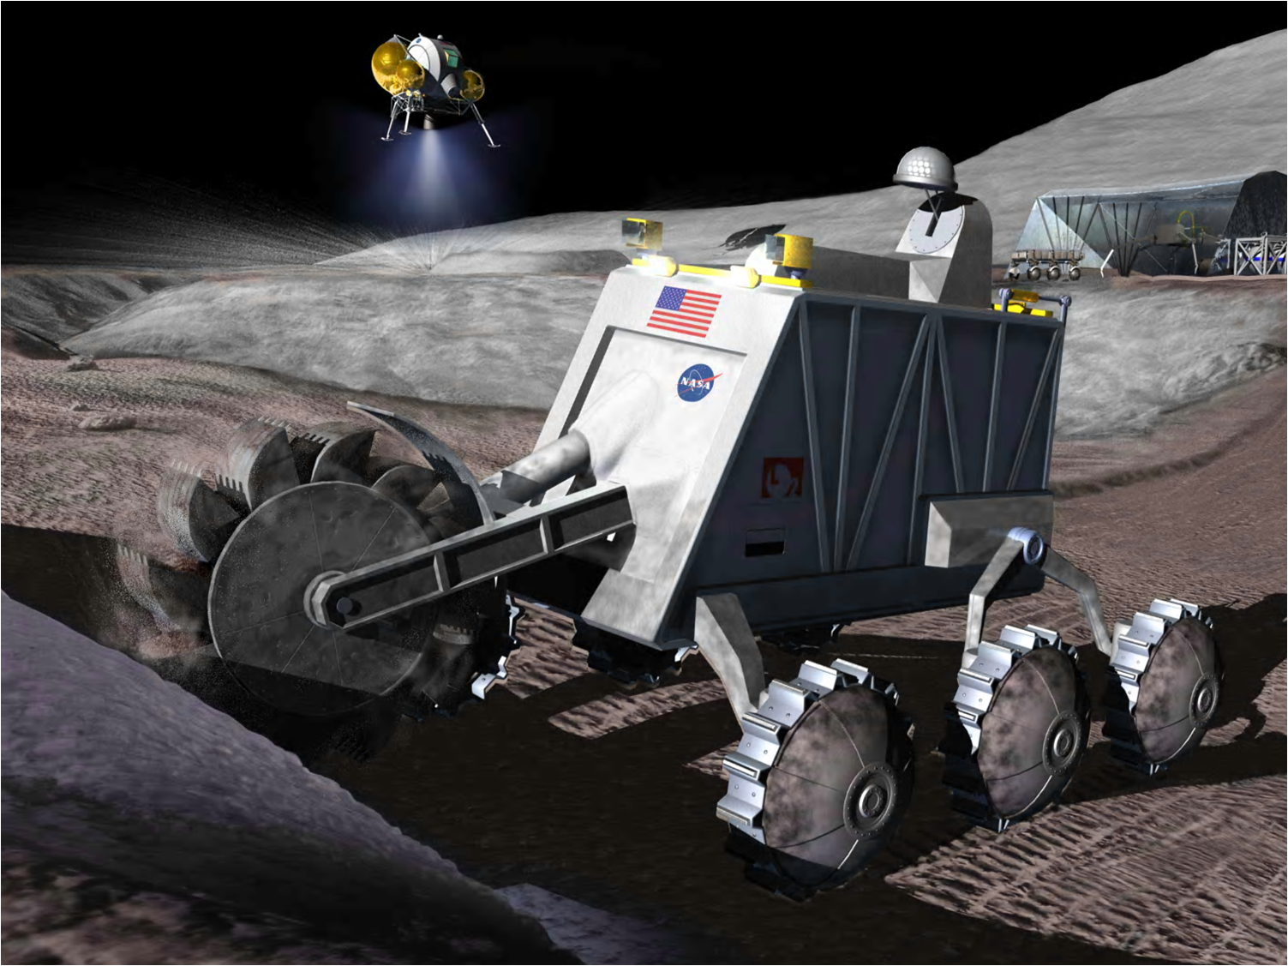

Figure 4 - Concept art for the NASA Lunabotics Competiton

# Industry Partnership

In return for financial support of the BLUEsat project, BLUEsat can offer widespread marketing opportunities and outreach to the some of the brightest future engineers in Australia. Any incentives can be negotiated to best suit ___(company)__. Potential incentives include:

### **___(company)__ branding on all BLUEsat materials**

BLUEsat sponsors will achieve significant publicity around UNSW, Sydney and internationally at space engineering design competitions. This will be achieved through branding on all BLUEsat clothing, posters and at events. In the aftermath of our April 2014 balloon launch, we also anticipate significant media coverage.

### **Access to talented engineers**

Sponsors of BLUEsat will be in contact with some of the top Electrical, Mechanical and Software engineering students in Australia. There will be opportunities for networking evenings where ___(company)__ can present and meet the student community. Members of the BLUEsat team are regularly graduating from university, and sponsorship of BLUEsat would provide a pathway for top students to work with ___(company)__.

### **Our name/affiliation**

Further opportunities for publicity are available through the purchase of BLUEsat’s name and affiliation (e.g. the ___(company)__ BLUEsat Project).

## BLUEsat Financial Objectives

There are three areas that BLUEsat is seeking project funding for. These include the 2014 satellite launch, NASA Lunabotics Competition and Canadian Satellite Design Challenge. An overview of the expected costs are outlined below:

### **2014 Launch Costs**

The 2014 launch currently presents the most significant investment for BLUEsat. This includes the cost of rebuilding the satellite, purchasing the stratospheric balloon, helium gas, parachute and the support hardware that is required. The total estimated cost is outlined below:

|  |  |  |
| --- | --- | --- |
| Item | Required Date | Projected Cost |
| Rebuilding flight model | March 2014 | $4400 |
| Launch cost | April 2014 | $28500 |
| Total |  | $32900 |

A detailed breakdown of these costs is included in Appendix A – BLUEsat Projected Budget.

### **NASA Lunabotics Competition**

Designing and building a mining robot to compete in the NASA Lunabotics Competition requires purchasing the chassis, control system components and raw parts. The projected cost of the project is outlined below:

|  |  |  |
| --- | --- | --- |
| Item | Date Required | Projected Cost |
| Raw Parts and Robot chassis | April 2014 | $7500 |
| COTS control systems | April 2014 | $7500 |
| Total |  | $15000 |

Travel to Florida and accommodation will also be required to attend the competition, however this has been included as an optional cost in the Budget as BLUEsat members may be able to cover their own costs.

## **Canadian Satellite Design Challenge**

Competing in the CSDC will involve purchasing the mechanical structure, subsystems and building the custom PCBs. This is predicted cost is outlined below:

|  |  |  |
| --- | --- | --- |
| Item | Date Required | Projected Cost |
| Mechanical structure | January 2015 | $5000 |
| Subsystems | January 2015 | $10000 |
| Custom PCBs | January 2015 | $2500 |
| Total |  | $17500 |

After the CSDC, there will be an opportunity to launch our designed satellite. This has been included in the budget as optional, as it represents a significant investment (projected cost of $50 000). The costs of travel to Canada and accommodation have also been included as optional, as BLUEsat members may be able to cover their own costs.

### **Ongoing Costs**

Ongoing costs include the upkeep of room, hosting events, publicity, recruitment and purchasing equipment, parts and software. The yearly costs are outlined below:

|  |  |  |
| --- | --- | --- |
| Item | Time Period | Projected Cost |
| Misc equipment and Room Costs | January 2015 | $6000 |
| Events and recruitment | January 2015 | $1400 |
| Total |  | $7400 |

A full budget has been included in Appendix A (Section 4.1).

We have estimated that operating costs for the next two years of the BLUEsat project will be $85 560 (including 20% contingency). However, this figure does not include optional expenses such as the launch of the CSDC CubeSat and accommodation to attend each of the competitions. Covering these costs would enable BLUEsat to achieve greater international reputation and more exposure for any partnering companies.

If ___(company)__ is interested in partnering with BLUEsat for any or all of our upcoming projects, please contact us to arrange a meeting and we can discuss the terms of the partnership.

Contact details:

**Thien Nguyen**

BLUEsat President

Email: tnguyen@bluesat.unsw.edu.au

Phone: 0424 375 683

**Cam Brown**

BLUEsat Chief Technical Officer

Email: cbrown@bluesat.unsw.edu.au

Phone: 0411 477 008

**James Roberts-Thomson**

BLUEsat Chief Operations Officer

Email: jrt@bluesat.unsw.edu.au

Phone: 0481 394 307

|  |  |  |  |  |  |
| --- | --- | --- | --- | --- | --- |
| Balloon Launch  By April 2014 | | | | | |
| Item | Need By | Unit Cost | Quantity | Total | Contingency (+20%) |
| Raven Aerostar 3990m3 Balloon | Mar-14 | $5,000 | 2 | $10,000 | $12,000 |
| Helium Gas | Mar-14 | $1,500 | 1 | $1,500 | $1,800 |
| Radio Uplink | Nov-13 | $750 | 1 | $750 | $900 |
| Radio Downlink | Nov-13 | $750 | 1 | $750 | $900 |
| Balloon Altimeter | Nov-13 | $2,000 | 1 | $2,000 | $2,400 |
| Balloon Termination Device | Nov-13 | $1,000 | 1 | $1,000 | $1,200 |
| Payload Recovery Parachute | Feb-14 | $3,000 | 1 | $3,000 | $3,600 |
| Parachute release device | Dec-13 | $1,000 | 1 | $1,000 | $1,200 |
| Secondary Power Supply - Lithium Non-Rechargable 28V 30Ah | Dec-13 | $2,000 | 1 | $2,000 | $2,400 |
| Recovery Costs | Apr-14 |  |  | 0 |  |
| Misc. Launch Hardware | Mar-14 | $5,000 | 1 | $5,000 | $6,000 |
| Personnel | Mar-14 |  | 5 | 0 |  |
| Transport Costs: Personnel + Hardware to Wagga Wagga (Optional) | Apr-14 | $500 | 1 | $500 | $600 |
| Accomodation (Optional) | Apr-14 | 200 | 5 | $1,000 | $1,200 |
| Total - Base | | | | $27,000 | $32,400 |
| Total - With Options | | | | $28,500 | $34,200 |

# Appendices

## Appenidx A – BLUEsat Projectd Budget

Industry Partnership Proposal

|  |  |  |  |  |  |
| --- | --- | --- | --- | --- | --- |
| Satellite Flight Model  By March 2014 | | | | | |
| Item | Need By | Unit Cost | Quantity | Total | Contingency (+20%) |
| Batteries | Jan-14 | $400 | 1 | $400 | $480 |
| Passive Components (Resistors, Capactiors etc) | Nov-13 | $500 | 1 | $500 | $600 |
| Integrated Circuits | Nov-13 | $700 | 1 | $700 | $840 |
| Custom PCBs (Set) | Nov-13 | $2,000 | 1 | $2,000 | $2,400 |
| Transmitter Radio + Tuning | Dec-13 | $400 | 1 | $400 | $480 |
| Reciever Radio + Tuning | Dec-13 | $400 | 1 | $400 | $480 |
| Mechanical Structure Fasteners (Non-Optional) | Dec-13 | $1,500 | 1 | $1,500 | $1,800 |
| Mechanical Structure - Labour and tooling (Optional) | Jan-14 | $8,500 | 1 | $8,500 | $10,200 |
|  |  |  | Total - Base | $4,400 | $5,280 |
|  |  |  | Total - With Options | $14,400 | $17,280 |

BLUEsat 12

Industry Partnership Proposal

|  |  |  |  |  |  |
| --- | --- | --- | --- | --- | --- |
| Lunabotics  By May 2015 | | | | | |
| Item | Need By | Unit Cost | Quantity | Total | Contingency (+20%) |
| Raw Parts and Robot Chassis | Apr-14 | $7,500 | 1 | $7,500 | $9,000 |
| COTS Control System and Components | Apr-14 | $7,500 | 1 | $7,500 | $9,000 |
| Travel + Accomodation to Florida (optional) | May-15 | $2,000 | 4 | $8,000 | $9,600 |
|  |  |  | Total - Base | $15,000 | $18,000 |
|  |  |  | Total - With Options | $23,000 | $27,600 |

Industry Partnership Proposal

|  |  |  |  |  |  |
| --- | --- | --- | --- | --- | --- |
| Canadian Space Design Challenge  By September 2015 | | | | | |
| Item | Need By | Unit Cost | Quantity | Total | Contingency (+20%) |
| Mechanical Structure | Jan-15 | $5,000 | 1 | $5,000 | $6,000 |
| COTS Subsystems | Jan-15 | $2,000 | 5 | $10,000 | $12,000 |
| Custom PCBs | Jan-15 | $500 | 5 | $2,500 | $3,000 |
| Travel and Accomodation (Optional) | Sep-15 | $2,000 | 5 | $10,000 | $12,000 |
| Launch (optional) | Jan-16 | $50,000 | 1 | $50,000 | $50,000 |
|  |  |  | Total - Base | $17,500 | $21,000 |
|  |  |  | Total - With Options | $77,500 | $71,000 |

Industry Partnership Proposal

|  |  |  |  |  |  |
| --- | --- | --- | --- | --- | --- |
| Ongoing Costs  2013-2015 | | | | | |
| Item | Need By | Unit Cost | Quantity | Total | Contingency (+20%) |
| Upkeep of room | 2013-2015 | $1,000 | 1 | $1,000 | $1,200 |
| Purchase of misc equipment | 2013-2015 | $5,000 | 1 | $5,000 | $6,000 |
| Events at UNSW | 2013-2015 | $80 | 10 | $800 | $960 |
| Recruitment costs (Promotional Material, etc) | 2013-2015 | $200 | 3 | $600 | $720 |
|  |  |  | Total | $7,400 | $8,880 |

|  |  |  |
| --- | --- | --- |
| Total Costs | | |
| Overall (Base Total) | $71,300 | $85,560 |
| Total (with Options) | $150,800 | $158,960 |